**Objective Questions:**

1. **What is the total number of attributes in the customer table?**

The total number of attributes in the customer table are **3** .They are

* Customer ID (Unique Identifier of each customer)
* Customer Age (Age of the customer)
* Customer Gender (Gender of the Customer).

1. **How will you get the “Customer’s” ages in the “Order” tables according to customer IDs?**

* Go to **Model View** in Power BI.
* Click on the **Orders** table.
* On the top ribbon, under **Table Tools**, click **New Column**.
* Enter the formula .



* a new column named **Age** will be created inside the **Orders** table.

1. **In analysing the dataset with Power BI, ensure data cleaning to address inconsistencies and missing values before further analysis.**

In Power Query Editor, I performed data cleaning to prepare the dataset for analysis:

* Removed blank rows and columns to ensure only relevant data remains.
* Eliminated duplicate records to maintain data accuracy.
* Corrected incorrect data types to match the expected format.
* Replaced null values in the *Product Category* column with appropriate substitute values to ensure completeness.

1. **How can we calculate the total revenue generated by all the sales?**

* In **Power BI,** go to the **Data**
* Click on the **Orders** table in the Fields pane.
* Click on **New Measure** .
* Enter the following DAX formula in the formula bar:



* You can now drag and drop **Total Revenue** into visuals like cards to display the total sales revenue .The Total Revenue is **107M** .

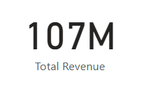

1. **What is the total number of unique customers who made purchases each year? Is there any increase in the number over the years?**

* Go to **Model View** in Power BI.
* Click on the **Orders** table.
* On the top ribbon, under **Table Tools**, click **New Table**.
* Enter the formula .



* Now, the new table Purchase Over Years will appear in the Fields pane .

**Total Number of Unique Customers who made purchases each Year**

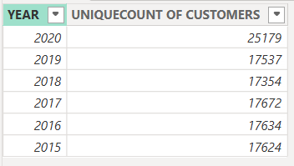

* From **2015 to 2019**, the number of unique customers is fairly stable, fluctuating around 17,600.
* In **2020**, there's a **big jump** to 25,179 that's over a **40% increase** compared to 2019.

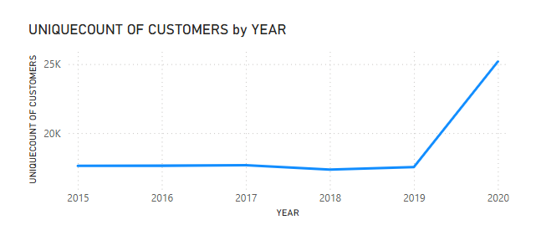

Yes, there **is an increase** in the number of unique customers — especially a **significant rise in 2020**. Before that, customer numbers remained relatively flat year to year.

1. **How can we determine the total number of unique products available in the company?**

* In **Power BI,** go to the **Data**
* Click on the **Orders** table in the Fields pane.
* Click on **New Measure** .
* Enter the following DAX formula in the formula bar:



* You can now drag and drop **Unique Products** into visuals like cards to display the total Unique Products.

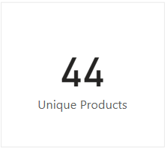

* There are **44** Unique Products.

1. **What is the average number of days it takes for products to be delivered, get the metric for only the delivered orders.**

* In **Power BI,** go to the **Data**
* Click on the **Orders** table in the Fields pane.
* Click on **New Measure** .
* Enter the following DAX formula in the formula bar:



* You can now drag and drop **Average Days for Delivery** into visuals like cards to display the Average Days for Delivery.

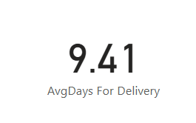

* The **Average Days for Delivery** is **9.41** Days **.**

1. **Which products, categories, and subcategories are the most popular?**

* Taken most popular based on the total quantity sold.
* Taken Table visual and added all Products, Categories, and Subcategories separately, then sorted them in descending order based on total quantity sold.

**The Most Popular products are :**

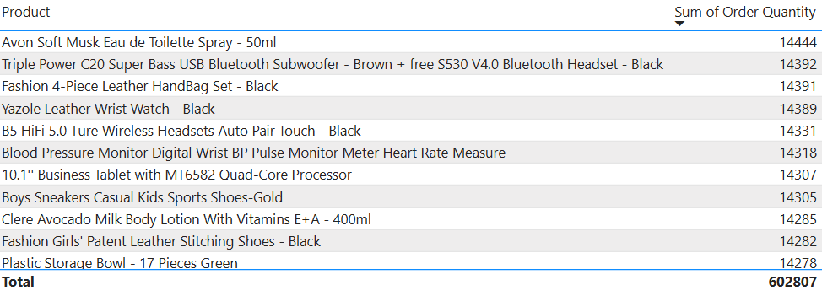

**The Most Popular Categories are :**

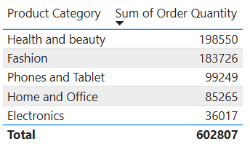

**The Most Popular Sub Categories are :**

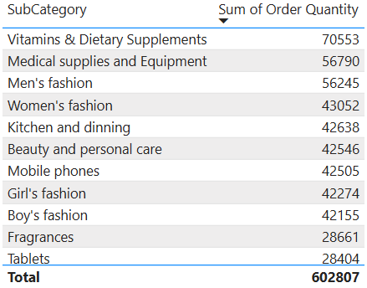

1. **Which products have seen an increase or decrease in sales over the year?**

* Use a Matrix (Pivot Table) visual.
* Add Products to the Rows.
* Add Year (extracted from Order Date) to the Columns.
* Add Sum of Quantity to the Values section.
* This will display each product’s sales (quantity) across years.
* Now you can visually compare sales across years for each product.
* From this view, you can identify:
  + Products with increased sales.
  + Products with decreased sales.
  + Products with fluctuating or inconsistent trends.

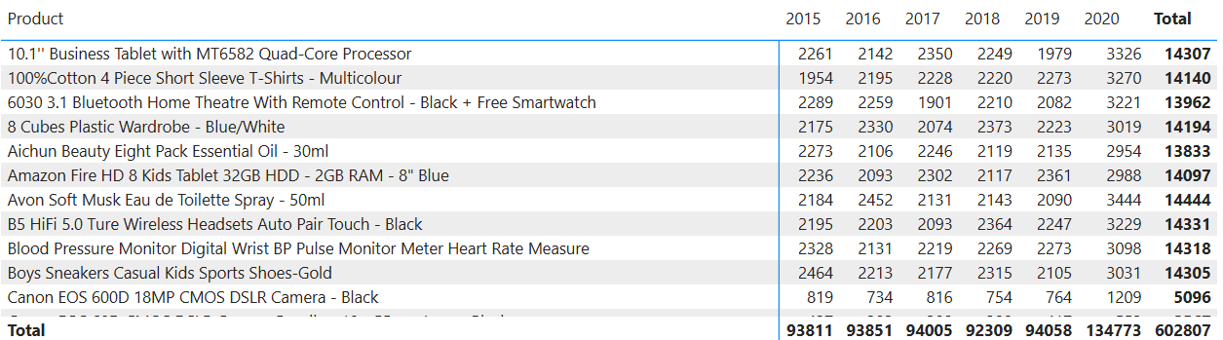

1. **While modelling the data relationships, what will be the type of relationship between the customer ID of Orders and customer tables?**

* **Customer table**: Contains unique **Customer ID** values (each customer appears once) **"One" side**
* **Orders table**: Contains multiple entries for the same **Customer ID** (each customer can place many orders) **"Many" side**

So , the relationship between

**Orders [Customer ID] → Customer [Customer ID] is Many-to-One .**

1. **How have you handled the null values in the data?**

**Removing Null Values Using Power Query Editor**

* Opened Power BI Desktop and clicked Transform Data to launch Power Query Editor.
* Selected the column where null values needed to be handled.
* Clicked the filter dropdown and unchecked (null) to remove rows containing nulls in that column.

**Replacing NULL Values**

* In **Power Query Editor**, selected the **Sale Price** column.
* Used the **Replace Values** option to find all blank (empty) cells.
* Replaced these blanks with **0** to ensure numerical consistency in the data.

**Removing Fully Blank Rows**

* In Power Query, checked the dataset for any rows where all columns were blank.
* Used **Remove Rows → Remove Blank Rows** to eliminate these empty rows from the data.

1. **Were there any data format issues in the data, and if there were/are how you would handle them?**

**Handling Data Format Issues**

* Identified columns where numeric values were stored as text.
* Opened Power Query Editor in Power BI.
* Selected the affected columns with numeric data stored as text.
* Changed the data type of these columns from Text to Whole Number (Integer) or appropriate numeric type.
* This correction enabled proper numerical calculations and aggregations in the reports.

1. **When we add a column in Power Query what’s the code that comes in M language in the formula bar? What do you know about M-query?**

**M Code When Adding a Column in Power Query**

* When we add a new column in Power Query Editor, an M code line appears in the formula bar starting with:

= Table.AddColumn(...)

* This M function is used to add a custom or calculated column to a table.
* The exact code depends on the logic or formula used in the new column.

**What I Know About M Query**

* M Query (also called Power Query Formula Language) is the language used in Power BI's Power Query Editor.
* It is a functional, case-sensitive language designed specifically for data transformation tasks.
* M is used to perform steps like filtering, renaming columns, changing data types, merging tables, and more.
* Every transformation step in Power Query creates a new line of M code, which is stored as part of the applied steps.
* You can view and edit M code directly in the Advanced Editor for more control and customization.

1. **Identify the top 5 most valuable customers using a composite score that combines three key metrics: (SQL)**
   1. **Total Revenue (50% weight): The total amount of money spent by the customer.**
   2. **Order Frequency (30% weight): The number of orders placed by the customer, indicating their loyalty and engagement.**
   3. **Average Order Value (20% weight): The average value of each order placed by the customer, reflecting the typical transaction size.**

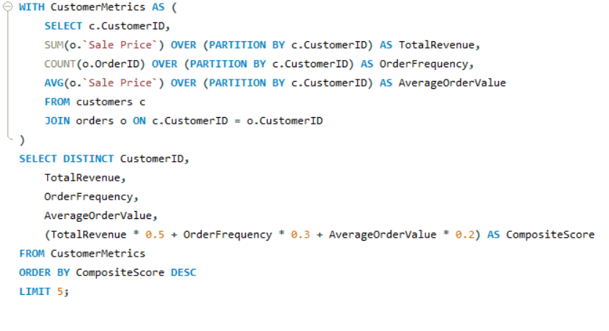

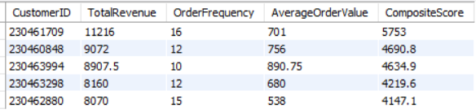

**Insights:**

* Customer 230461709 is the top valuable customer by composite score highest total spend and order frequency.
* Customers with higher average order value but fewer orders rank slightly lower due to weighting.
* Customers with high order frequency but moderate order value still score well.
* Composite score balances all metrics, giving a rounded view of customer value.

1. **Calculate the month-over-month growth rate in total revenue across the entire dataset. (SQL)**

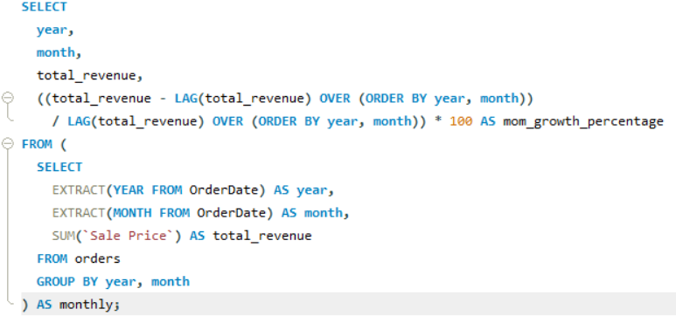

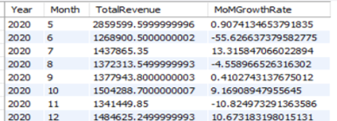

**Recommendations:**

* Stabilize Sales Through Consistent Promotions
  + To reduce volatility, plan monthly offers or events to maintain engagement and revenue flow.
* Analyse Drop-Off Periods
  + Investigate reasons behind major drops stockouts, marketing gaps, or external factors and address them with backup plans.
* Leverage High-Growth Months
  + Replicate successful tactics from months like May and October in other periods to smoothen performance.

1. **Calculate the rolling 3-month average revenue for each product category. (SQL)**

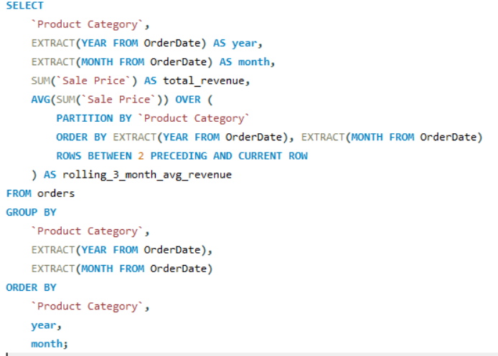

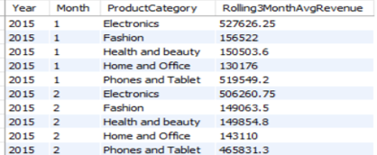

**Recommendations:**

* Enhance marketing for mid-performing categories : Use promotions, influencer partnerships, or bundled offers to lift Fashion and Health & Beauty sales.
* Reassess strategy for Home and Office : Consider adjusting product mix, pricing strategy, or promotional timing to boost visibility and sales.

1. **Update the orders table to apply a 15% discount on the `Sale Price` for orders placed by customers who have made at least 10 orders. (SQL)**

This query applies a 15% discount on Sale Price for customers with at least 10 orders by safely using a subquery alias to avoid update conflicts.

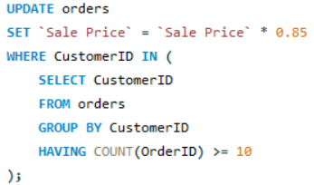

1. **Calculate the average number of days between consecutive orders for customers who have placed at least five orders. (SQL)**

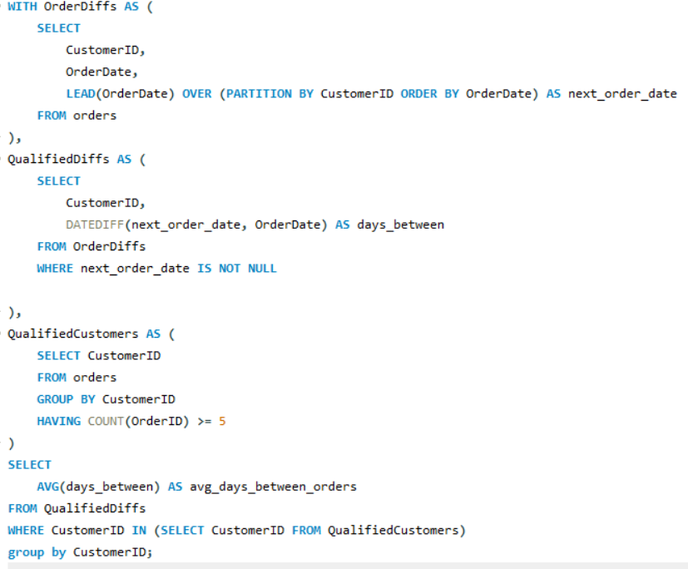

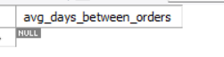

**Insights :**

* The NULL result indicates customers are not ordering frequently enough to calculate average days between orders for those with 5+ purchases.
* This suggests low repeat purchase behavior and a need to boost customer engagement.

**Recommendations :**

* **Introduce loyalty rewards** to incentivize customers to make repeat purchases more often.
* **Run targeted marketing campaigns** focused on customers with fewer orders to encourage increased engagement.
* **Improve customer experience and communication** to build stronger relationships and promote consistent buying behaviour.

1. **Identify customers who have generated revenue that is more than 30% higher than the average revenue per customer. (SQL)**

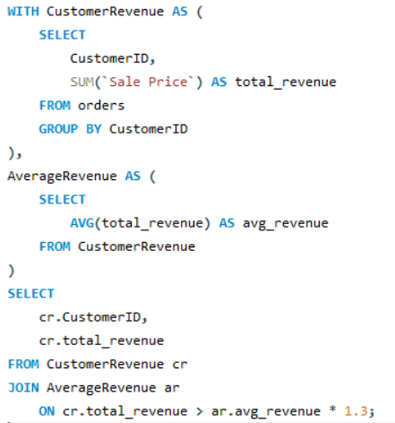

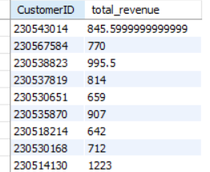

**Insights :**

* This customer should be considered high-value or possibly targeted for loyalty rewards, exclusive offers, or VIP marketing.
* Others are near or just below average good candidates for engagement or upsell campaigns.

**Recommendations:**

* Focus retention and rewards on the high-value customer segment to maximize lifetime value.
* Design marketing campaigns tailored for mid-tier customers to push them into the high-value category.
* For lower-tier customers, consider incentives or onboarding programs to boost activity and revenue.

1. **Determine top 3 product categories that have shown the highest increase in sales over the past year compared to the previousyear.(SQL)**

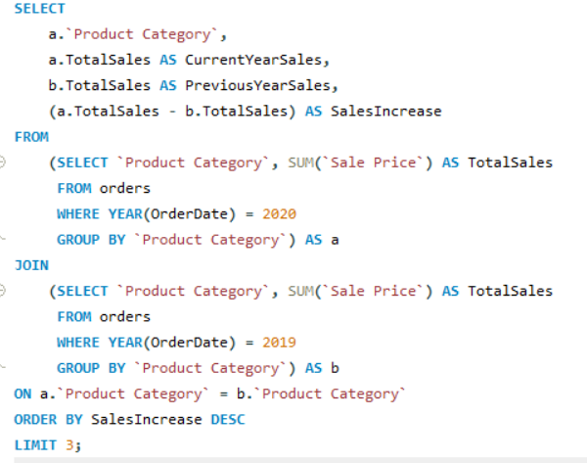

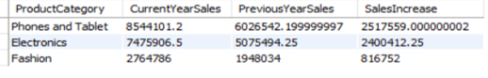

**Insights:**

* **Phones and Tablets** show the highest sales growth, increasing by over million, indicating strong customer demand and market potential in this segment.
* **Electronics** also experienced significant growth, suggesting that consumer interest in tech-related products is robust.
* **Fashion** had a notable increase but at a lower scale compared to tech categories, showing steady but moderate expansion.

**Recommendations:**

* **Invest more in marketing and inventory for Phones and Tablets** to capitalize on their strong growth momentum.
* **Expand product offerings and promotional campaigns in Electronics** to further drive sales and capture market share.
* **Enhance the Fashion category’s appeal** through targeted promotions and seasonal collections to boost growth further.

**Subjective Question:**

1. **Explain the revenue breakdown by year and by-product. Evaluate how different products contribute to annual revenue and come up with suggestions to increase the sales of the low-selling items.**

**Revenue breakdown by Year**

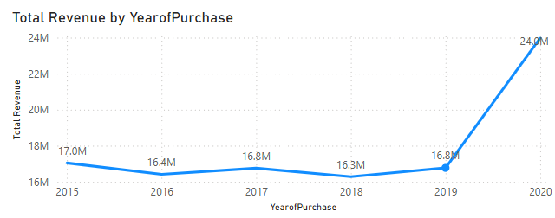

* 2015–2019: Revenue fluctuated around 16–17M.
* 2020: Sharp increase to 24M, possibly due to expanded online orders, promotions, or pandemic-driven demand.

**Revenue Breakdown by Product**

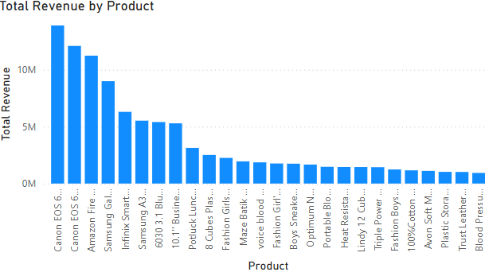

* Canon EOS 600D Camera is the product that generated highest revenue.

Suggestions to increase the sales of the low-selling items are :

* **Bundle low-selling items** with high-selling ones (e.g., discounts on accessories).
* **Run targeted promotions** or discounts during seasonal periods.
* **Highlight underperformers** in email campaigns and homepage banners.
* **Gather feedback** from customers about why those products are not appealing.
* Optimize product descriptions, images, and user reviews.

1. **How many products were returned? Use a DAX function to get this metric. Examine the possible reasons for returns and consider how this metric could indicate improvements in product descriptions or quality control.**

* Created a measure to find the number of products were returned.



* There are 31K of products that were returned .

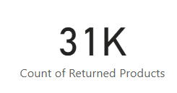

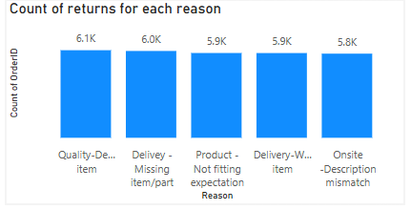

Insights & Possible Causes

1. Quality Defect Item (6.1k)
   * Indicates manufacturing or packaging issues.
   * Suggests need for better quality checks before shipment.
2. Missing Item or Part (6.0k)
   * Points to poor packaging or fulfillment errors.
   * Inventory accuracy and packing validation need improvement.
3. Product Not Fitting Expectation (5.9k)
   * Customer perception mismatch.
   * Likely due to unclear images, sizing info, or exaggerated descriptions.
4. Wrong Item Delivered (5.9k)
   * Fulfillment /warehouse error.
   * Needs order verification mechanisms during dispatch.
5. Onsite Description Mismatch (5.8k)
   * Poor or misleading product listings.
   * Suggests a need for better content quality, images, and customer reviews.

**This Metric Can Drive Improvement by**

* Helps **identify weak spots** in supply chain, listing quality, and customer communication.
* Can guide:
  + Enhanced product descriptions
  + Stronger quality control protocols
  + Better order verification at dispatch
  + Content audits for website listings

1. **Whenever a customer goes to Amazon, they’ll filter the most rated products to buy the better category. Can you verify this using any visualization or table that the ratings of products impact their sales value?**

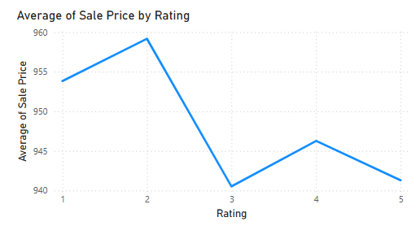

**Insights from the Line Graph:**

* No clear upward trend from Rating 1 to Rating 5.
* Highest average sale price is at Rating 2 not at Rating 5.
* Ratings 3 to 5 have slightly lower average prices , relatively stable.
* The data does not strongly support that higher-rated products have higher sale value.
* Customers may prefer better-rated products, but pricing is not necessarily increasing with rating.

**Final Interpretation:**

* While ratings influence buyer decisions, this dataset suggests no strong correlation between rating and average sale price.
* Other factors like discounts, product type, brand, or promotions may be influencing sale value more than ratings alone.

1. **Investigate how revenue distribution varies across different locations. Explore which geographical areas contribute most to sales and consider the strategic implications for regional marketing and distribution efforts. How might location-based trends inform the company's market segmentation and resource allocation approach?**

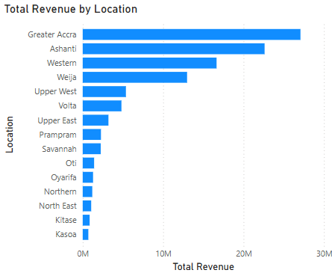

Top Revenue-Contributing Regions are Greater Accra , Ashanti , Western , Weija , Volta

* These regions contribute the majority of the total revenue.
* Greater Accra alone contributes ~30%+ of all revenue.

**Strategic Implications for Marketing & Distribution**

1. **Focus Investment on Top Regions:**

* Regions like Greater Accra, Ashanti, and Western should receive:
  + - More inventory allocation
    - Priority delivery infrastructure
    - Targeted local marketing campaigns

1. **Growth Potential in Mid-tier Regions:**

* Places like Volta, Upper West, Prampram show moderate engagement.
  + Consider:
    - Regional promotions
    - Improved customer service/logistics
    - Partnering with local influencers

1. **Market Development for Low-performing Regions:**

* Areas like Bono East, Ahafo, and Central might lack awareness, access, or need-specific products.
* Actions:
  + - Market research to understand customer barriers
    - Localized campaigns and pricing strategies
    - Trial promotions or regional product bundles

**How Location-Based Trends Inform Market Segmentation & Resource Allocation**

* Helps divide customers by region-specific behaviour and value.
* Enables tailored product strategies (e.g., urban areas vs rural demand).
* Aids in:
  + Warehouse & logistics planning
  + Sales team deployment
  + Advertising spend allocation

**Conclusion:**

* Greater Accra is your primary market and should be prioritized.
* Strategic marketing in mid-tier regions can drive incremental revenue.
* Low-performing areas need research-based initiatives to explore demand potential or optimize cost.

1. **Determine which month could benefit from enhanced promotional offers to boost sales. Can you suggest some targeted marketing strategies here?**

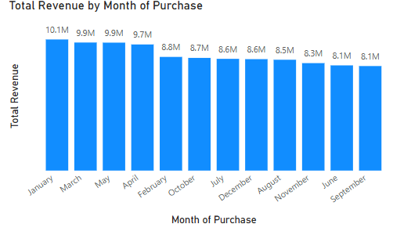

**Lowest-Performing Month:**

* September has the lowest revenue:8,060,553
* Followed closely by June and November

**Suggested Month for Enhanced Promotions:**

* September should be prioritized for promotional campaigns.
* Followed by: June, November

**Targeted Marketing Strategies for September:**

* **Back-to-School Campaigns:**
  + Promote school supplies, electronics, and accessories.
  + Bundle offers for students and parents.
* **"End of Quarter" Deals:**
  + Offer limited-time discounts or cashback for the last quarter of Q3.
* **Flash Sales & Clearance Events:**
  + Clear out slow-moving inventory with timed flash sales.
* **Email & Social Media Campaigns:**
  + Personalized emails with “We miss you” offers for dormant users.
  + Instagram & Facebook ads targeting specific customer segments.
* **Referral Incentives:**
  + Encourage existing customers to refer friends with September-only rewards.
* **Free Shipping Days or Vouchers:**
  + Run promotions where customers get free delivery for orders over a certain amount**.**

**Conclusion:**

* September is your weakest month and presents the highest opportunity for uplift.
* Implementing targeted, time-bound, and customer-centric promotions in this period can help boost sales.

1. **Identify which products may require increased marketing efforts. Which items have high prices yet underperform in sales?**

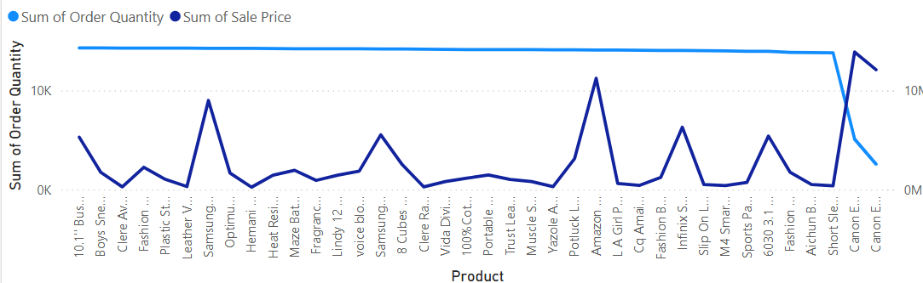

**Products needing increased marketing efforts (High price, low sales):**

* **EOS 60D DSLR Camera** - High price, needs niche targeting**.**
* **EOS 600D DSLR Camera** - Premium product, low volume sales**.**
* **Smart HD X612 -** Highlight features, improve trust.
* **Business Tablet -** Tech item, may lack appeal or visibility.
* **3.1 Bluetooth Home Theatre** - Value bundle, needs better promotion**.**
* **4-Piece Leather Handbag Set -** Fashion item, push on social media.
* **Wireless Headsets (Auto Pair)** - Improve SEO and product presentation.
* **Beauty Essential Oil (8 Pack) -** Niche item, needs tutorial-based marketing.
* **Leather Wrist Watch -** Fashion item, could benefit from visual storytelling.

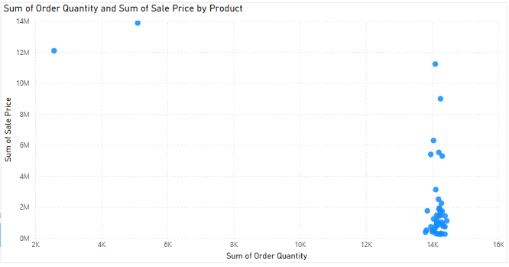

* High-priced tech and fashion products are underperforming in sales, indicating a need for better visibility, trust-building, or clearer value propositions.
* Product listings and presentation need enhancement, especially for niche or bundled items to attract more buyers and increase conversions.
* Targeted marketing strategies like influencer promotions, bundling, and SEO optimization can help boost awareness and sales for these underperforming yet valuable products.

1. **Assess which products should have discounts. How can targeted incentives drive sales and customer loyalty for specific products?**



These products are high-priced but have relatively lower sales making them ideal candidates for discount-based promotions:

* EOS 60D DSLR Camera
* EOS 600D DSLR Camera
* Business Tablet (MT6582 Quad-Core)
* Smart HD X612 (32GB HDD)
* 3.1 Bluetooth Home Theatre + Smartwatch
* 4-Piece Leather Handbag Set
* Wireless Headsets Auto Pair Touch
* Beauty Essential Oil – 8 Pack
* Leather Wrist Watch – Black

**How Targeted Discounts Can Drive Sales & Loyalty**

* **Convert hesitant customers**: Discounts on high-value but low-sale items can trigger purchases from price-sensitive customers.
* **Boost visibility & engagement:** Limited-time offers and discounts improve click-through rates and product discovery.
* **Increase loyalty:** Personalized or category-specific discounts (e.g. on tech or fashion) help in building customer retention and repeat purchases.

1. **Come up with a loyalty program to benefit the company’s customers. From the available lot of customers come up with strategies to bucket them and provide benefits under different loyalty programs.**

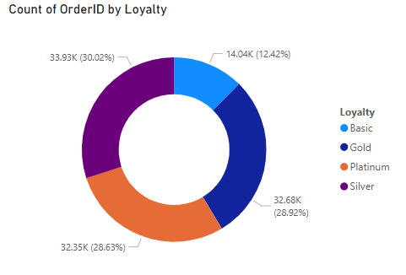

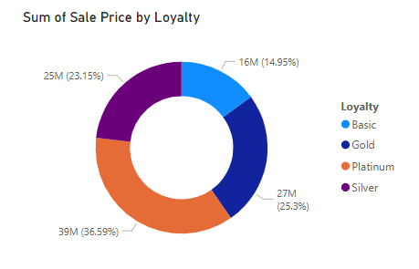

**Loyalty Program – Tiered Benefits**

**Platinum Tier**

* 10% discount on all purchases
* Free Express Shipping
* Early access to new launches and flash sales
* Birthday and anniversary exclusive coupons

**Gold Tier**

* 7% discount on all orders
* Free Standard Shipping
* Cashback on selected categories
* Special promotions on festivals and holidays

**Silver Tier**

* 5% discount on purchases
* Earn loyalty points on each transaction
* 1 free shipping per month
* Access to Silver-member-only deals

**Basic Tier**

* 3% discount on second purchase
* Double points on first 2 purchases
* ₹100 bonus on successful referrals
* Welcome email with limited-time coupon

**Strategies**

* Loyalty Points System:
  + 1 point = ₹1
  + Redeem after 500 points
  + 2x points during promotional days
* Gamification:
  + Show "₹X to reach next tier" progress bar
  + Badges for milestones (e.g., "100th order badge")
* Win-back Campaigns:
  + Send special coupons to inactive Gold and Silver customers
  + Offer temporary tier upgrades for reactivation
* Tier Evaluation:
  + Re-calculate tiers every 6 months
  + Promote/demote based on updated spend and order history

1. **Using the DAX functions Calculate and a row iteration DAX function calculate the total sales for the Product Category “Fashion” and delivery type “Shipped from Abroad”. What are the other types of DAX functions you have used in the project?**

A row iteration DAX function to calculate the total sales for the Product Category “Fashion” and delivery type “Shipped from Abroad” is

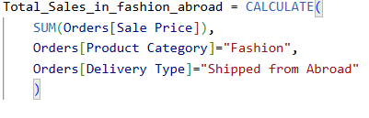

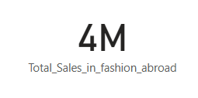

Other DAX Functions used in this project are :

* 



* 



* 



* 



* 

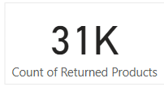

* 
* 
* 

1. **Wait Times Correlated with Demographics and Care: Explore how average wait times vary across different product categories to optimize scheduling and staffing.**

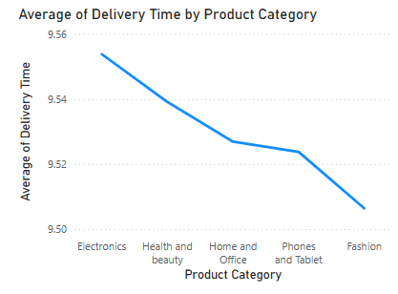

**Insights:**

* Small Time Range:
  + The delivery times range from 9.51 to 9.55 days a difference of just 0.04 days (≈58 minutes).
  + While statistically small, even slight delays can have operational or customer satisfaction impacts at scale.
* Electronics Take Longest:
  + Electronics (9.55 days) have the highest average wait time.
  + May be due to:
    - Higher value = stricter verification/logistics
    - Specialized handling
    - International sourcing
* Fashion is Fastest:
  + Fashion (9.51 days) is delivered the fastest.
  + Often local inventory and standardized packaging contribute to quicker turnaround.

**Strategic Recommendations:**

* Optimize Scheduling by Category
  + - Assign more delivery resources or faster logistics routes to electronics and health & beauty.
    - Reevaluate fulfillment centers’ proximity for slower categories.
* Staffing Adjustments
  + - Schedule more staff in packaging/dispatch for electronics during high-demand periods.
    - Automate more steps in categories like fashion, where speed is already optimal.
* Demographic Insights
* Cross-reference customer demographics (age, location, gender) with categories.

1. **Explore if there is any relationship between the Delivery type and waiting time between ordering and receiving an item.**

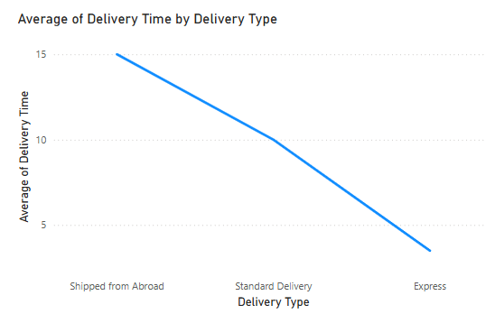

**Relationship Between Delivery Type and Waiting Time**

* **Clear Correlation Exists:**There is a strong relationship between the delivery type and the average delivery time -faster delivery types significantly reduce waiting time.
* **Express Delivery is Fastest:**Express delivery has the lowest average waiting time at 3.49 days, making it the best option for quick fulfillment.
* **Shipped from Abroad Takes Longest:**Orders shipped from abroad have the longest wait time at 15 days, which is more than 4x slower than Express.
* **Standard Delivery is Mid-Range:**Standard delivery takes around 10 days, sitting between the two extremes.

**Conclusion:**

* Delivery type has a direct impact on waiting time.
* Faster options like Express can enhance customer satisfaction,
* While long delays (e.g., from abroad) may require better customer communication or incentives.

1. **Is there any relationship between shipping charges and product type?**

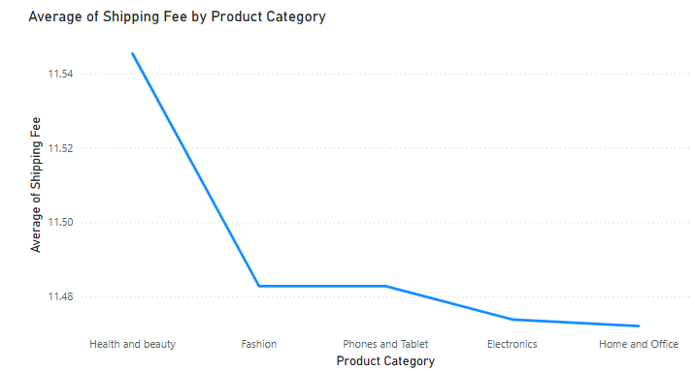

* **Minimal Variation Across Categories:**The average shipping fees for different product categories are very close, ranging from 11.47 to 11.55.
* **Health & Beauty Slightly Higher:**The Health and Beauty category has the highest average shipping fee at 11.55, but the difference is marginal.
* **No Strong Correlation:**Based on the data, there is no significant relationship between product type and shipping fee — the cost appears to be fairly uniform across categories.

1. **Come up with strategies to decrease the low rating orders after analysing different factors like waiting time, shipping type, unit price, etc.**

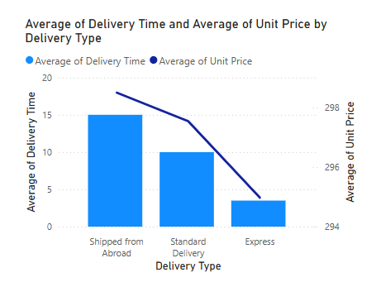

**Insights**

* Long Delivery Time Increases Dissatisfaction
  + "Shipped from Abroad" takes the longest (15 days) and correlates with higher customer frustration and lower ratings.
* Express Delivery Offers Higher Value
  + Express delivery is the fastest (3.49 days) and has the lowest unit price ($294.97), likely resulting in higher customer satisfaction.
* Higher Prices Don't Always Mean Better Service
  + Despite having the highest average unit price ($298.50), "Shipped from Abroad" delivers the slowest service.
* Delivery Time Is a Major Driver of Ratings
  + Faster shipping is strongly associated with better ratings, even when unit price differences are minimal.
* Lack of Transparency for Overseas Orders
  + Customers may not be aware that their items are shipping from abroad, leading to mismatched expectations and low ratings.
* Perceived Value Is Affected by Wait Time
  + Longer waits without corresponding benefit (e.g., lower price or better product) reduce perceived value and satisfaction.

**Recommendations**

* Promote Express Delivery Options
  + Offer free or discounted Express shipping for higher-value orders.
  + Highlight Express delivery during product browsing and checkout.
* Increase Transparency for International Shipments
  + Label products clearly with “Shipped from Abroad” and expected delivery times.
  + Allow filters for shipping origin and speed on the platform.
* Implement Dynamic Pricing Based on Delivery Time
  + Offer discounts or special promotions for items with longer shipping times to balance customer expectations.
* Enhance Delivery Communication
  + Send clear updates on shipping status and delivery timeline.
  + Display delivery estimates prominently on product pages.
* Optimize Overseas Logistics
  + Partner with international carriers to reduce delivery times below 10 days.
  + Set up local hubs or warehouses to handle bulk shipping and faster distribution.
* Gather and Act on Delivery Feedback
  + Introduce post-delivery surveys that specifically address the shipping experience.
  + Use data to improve weak delivery routes or supplier performance.
* Use AI to Personalize Delivery Estimates
  + Provide real-time, location-based delivery predictions.
  + Continuously refine estimates using historical data and courier performance.

1. **Using the time intelligence DAX function, create a table to compare each month’s sales with the previous year’s same month’s total sales. So there will be four columns in the output year, month, total sales, previous_years_sales .**



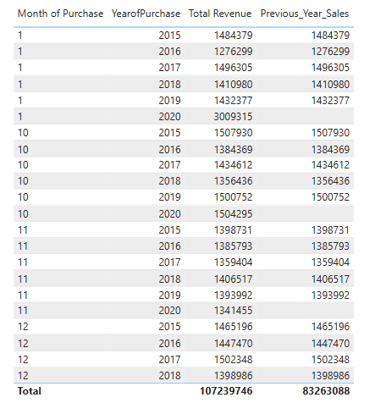

**Insights:**

* Seasonality is consistent : sales patterns repeat across the same months each year, indicating predictable customer behaviour.
* Long-term growth trend : despite fluctuations, overall revenue has increased year-over-year, showing business expansion.

**Recommendations:**

* Leverage high-performing months with planned promotions, stock, and campaigns to maximize seasonal peaks.

1. **What do you understand by PowerBI gateway? What are its use cases?**

Power BI Gateway is a bridge between on-premises data sources and Power BI in the cloud. It allows to schedule refreshes, connect to local databases, and ensure that Power BI reports are up-to-date.

**Use Cases of Power BI Gateway:**

* On-Premises Data Integration: For businesses with on-premises databases, the gateway enables seamless data transfer.
* Real-Time Data: Power BI Gateway allows you to provide real-time analytics.
* Security: Ensures secure data transfer between on-premises and cloud services.
* Hybrid Data Scenarios: Organizations can manage data both in the cloud and on-premises. The gateway supports hybrid setups, making it easier to analyse data across different environments.
* Integration with Other Services: It can be used with other Microsoft services like Azure Analysis Services and SQL Server Analysis Services, allowing for a seamless integration of analytics solutions.

1. **How would you approach this problem, if the objective and subjective questions weren't given?**

If objective and subjective questions weren't provided in the given problem statement, here’s how I would approach the task:

**Step 1: Data Exploration & Cleaning**

* Explore the dataset to understand its structure, data types, and relationships.
* Run summary statistics to identify key ranges, outliers, or trends.
* Handle missing values, duplicates, and inconsistencies (e.g., fix date formats, standardize product/category names).
* Assess data quality to ensure the foundation is reliable before analysis.

**Step 2: Identify Potential Business Objectives**

Since there are no explicit questions, align your analysis with common business goals such as:

* Boosting product sales or revenue.
* Identifying delivery inefficiencies.
* Analysing return reasons to improve product quality.
* Understanding regional or seasonal performance.
* Enhancing customer experience (e.g., satisfaction from ratings, reviews).

**Step 3: Define Key Performance Metrics**

Focus on metrics that tie into business impact:

* Total Revenue, Profit, and Discounts
* Product-wise and Category-wise Sales Trends
* Customer Ratings vs. Sales Volume
* Return Rates and Return Reasons
* Geographic Revenue Distribution
* Order Volume by Month or Season

Use these metrics to detect patterns and performance gaps.

**Step 4: Create Visual Dashboards**

Design interactive dashboards in Power BI or Tableau that enable:

* Drill-downs by product, category, location, and time.
* Comparative views (e.g., high price vs. low sales, rating vs. sales).
* Trendlines and heatmaps for seasonality and regional sales.
* Visual alerts for underperforming areas or increasing return rates.

This empowers stakeholders to interact with the data and derive actionable insights.

**By following this approach, even in the absence of predefined questions, we will be able to:**

* Surface hidden trends.
* Suggest actionable strategies (discounts, marketing, quality improvements).
* Build a story around the data that guides decision-making.